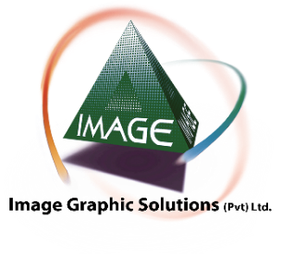
IGS ENVIRONMENTAL POLICY

Image Graphics Solutions (Pvt) Ltd. (IGS) regards itself as an environmentally conscious company that continuously aims to minimize the environmental impact of its business activities. In order to operate in harmony with the environment IGS focuses on the following elements:
- Recycling and Re-using of Material used in the manufacturing process.
- Efficient consumption of Energy and Natural Resources.
- Careful Handling of Hazardous Materials
- Systematic Waste Management

Recycling and Reusing Material
With the use of a variety of different materials, IGS ensures that all materials that are used are sourced from environmentally sustainable suppliers which provide long term warrantied solutions. Furthermore, once a project is complete, material that is no longer needed is disassembled and re-used at various stages of the production and installation process such as product packaging.

Efficient Consumption of Energy and Natural Resources.
Within the organization all employees are responsible to ensure that energy and other natural resources are conserved and therefore the usage is kept to a minimum. Department heads are to train and inform their employees so they are able to adopt the best practices relevant to their specific departments. IGS also works to reduce vehicle emissions by planning the most efficient routes for transportation.
Careful Handling of Hazardous Materials
All relevant departments are trained to handle hazardous material with the utmost care. All necessary safety equipment is provided to employees to ensure the safe handling of hazardous materials. Department heads are to ensure that safety equipment is readily available at all times.

Systematic Waste Management
Any material that is not re-used or re-cycled is first separated according to type of waste and is then disposed of in a safe way that minimizes the adverse effect on the environment. When dealing with hazardous materials all waste is securely contained and employees are strictly instructed to follow disposal instructions as listed on the packaging of the materials.
IGS makes sure to incorporate environmentally sustainable practices in all stages of production, from manufacturing to transportation right to installation. All IGS vendors and suppliers are trained and given all necessary information to enable them to function in a manner that avoids damage to the environment. IGS continuously seeks opportunities to improve its environmental performance by setting goals and encouraging employees to measure their performance on a regular basis.

_____________

